Results of the Conference

Energy Renovation of Traditional Buildings –
Tools and Techniques

On 5th November 2013, the conference "Energy renovation of traditional buildings – Tools and techniques" was held in the event room of the Pollein Grand Place area. It was organised by the regional Department of Productive Activities of the Regione Autonoma Valle d'Aosta and COA energia Finaosta with the patronage of the regional professional Orders and Colleges.

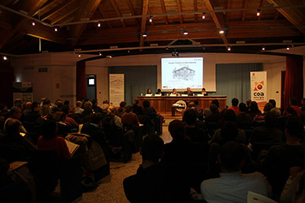

The conference presented the publication "Quaderno per il recupero energetico – Raccolta di casi studio per interventi sul patrimonio edilizio tradizionale", a handbook for energy recovery published within the European project AlpHouse and coordinated by COA energia and the Department in collaboration with the Fraunhofer Institute. The handbook suggests a new approach methodology for energy recovery of traditional architecture, the aim of which is to combine the themes of energy saving and quality of living with the preservation of the historical heritage, whilst supporting the design process and implementation of interventions.

An important section of the publication is dedicated to a collection of technical analysis that contains good practices of intervention on traditional building construction elements and nodes. For each part of the construction, the thermal and hygrometric parameters have been evaluated before and after the energy renovation interventions proposing solutions that respect the matters related to the protection of the buildings and regulations.

In this way, the professionals can have a useful tool to better understand the problems related to the complexity of these actions, to be guided in the choice of materials and in the techniques of intervention. The publication has been designed as a tool that can be implemented with new case-studies from other research projects, but also from practice and professional experience.

More than 800 professionals have been involved in the various events organized within the European project AlpHouse, and once again the interest in these main themes has been confirmed on this occasion by the more than 200 participants attending the conference.

The support activities for designers and all the players involved in the building process will continue in the European project AlpBC (Alpine Building Culture) which, in continuity with AlpHouse, will further explore the issues related to the sustainable development of the construction sector in the Alps, with a particular focus on the integration of energy issues in spatial planning.

